

American International University- Bangladesh

CSC 4261: Advanced Programming in Web Technology

CO1 Evaluation

Project Report

Summer 22-23

Project Title: TRI GARDENING

Project Domain: E-commerce

Section: B

Group No: 7

|  |  |
| --- | --- |
| Student Name | Student Id |
| PROSIT KUMAR DAS | 20-44063-2 |
| AMINUL ISLAM SAGOR | 20-44105-2 |
| MEHEDI HASAN RABBI | 20-44059-2 |
| NAFIS FUAD NIROB | 20-44082-2 |

Introduction:

*The project of creating an agriculture digitalization website with features for plant care information, selling and buying services, delivery services, and community engagement is being proposed to address the problem of lack of knowledge about plant care and to promote the benefits of indoor plants. This project aims to provide a comprehensive solution that can make a positive impact on agriculture and plant care knowledge in the country. By creating a user-friendly platform that offers valuable resources and services, the project can help users overcome the challenges of plant care and foster a sense of community around gardening. The project may also have commercial benefits for sellers and deliverymen, as it can provide a platform for them to reach a wider audience and offer their services more efficiently.*

Problem Analysis

*The problem statement for the proposed project is the lack of knowledge about plant care and the need to promote the benefits of indoor plants. Many individuals who are interested in gardening or indoor plants often struggle with understanding the specific care requirements of different plant species. This lack of knowledge can lead to poor plant health, limited growth, and even plant mortality. Furthermore, there is a need to create awareness about the positive impacts of indoor plants on air quality, mental well-being, and overall environmental sustainability.*

*Solving the problem of lack of knowledge about plant care and promoting the benefits of indoor plants is significant for several reasons:*

1. ***Education and Empowerment:*** *Providing valuable resources and information about plant care empowers individuals to take better care of their plants, leading to healthier and more vibrant indoor environments.*
2. ***Environmental Impact:*** *Promoting indoor plants helps improve air quality by reducing pollutants and increasing oxygen levels. This can have a positive impact on individuals' health and well-being while contributing to environmental sustainability.*
3. ***Community Engagement:*** *Creating a platform that fosters a sense of community around gardening encourages knowledge sharing, inspiration, and support among plant enthusiasts. This strengthens the gardening community and promotes social interactions.*
4. ***Economic Opportunities:*** *By facilitating buying and selling services, the project can support local businesses, nurseries, and delivery personnel, creating economic opportunities and contributing to the growth of the agricultural sector.*

***Existing Solutions:*** *There are several existing websites and platforms that address the problem of plant care and promotion of indoor plants. Here are a few examples:*

1. ***The Spruce:*** *(*[*www.thespruce.com*](http://www.thespruce.com/)*) The Spruce is a comprehensive website that provides articles, guides, and tutorials on various topics, including plant care. They offer detailed information on plant selection, care tips, and troubleshooting guides.*
2. ***PlantSnap:*** *(*[*www.plantsnap.com*](http://www.plantsnap.com/)*) PlantSnap is a mobile app that helps users identify plants by taking photos. It uses image recognition technology to provide accurate plant identification and offers information about each identified plant's care requirements. The app also has a community feature where users can upload their plant photos and interact with fellow plant enthusiasts.*
3. ***Etsy:*** *(*[*www.etsy.com*](http://www.etsy.com/)*) Etsy is an e-commerce website that hosts various sellers offering a wide range of indoor plants, planters, and gardening supplies. It provides a platform for sellers to showcase their products, and users can browse and purchase items directly from different sellers. The website offers user reviews and ratings to aid in decision-making.*

Feature Analysis:

1. User Category:

There are 4-types of Users here. They are:

* ADMIN
* SELLER
* CUSTOMER
* DELIVERY MAN

1. Feature List:

In this project the “Admin” has the following features:

• Admin can Manage/modify user accounts.

• Admin can log in.

• Admin can Delete user accounts.

• Admin can Manage/modify products list.

• Admin can organize product categories, prices, descriptions, and images.

• Admin can View/manage process orders.

• Admin can Track stock levels and initiate product reordering.

• Admin can Update inventory status to reflect product availability.

• Admin can analyze user activity platform performance data.

• Admin can manage platform content including images, text, and multimedia.

• Amin can ensure platform security/privacy including access control.

• Admin can generate reports on user activity, sales, and platform performance.

• Admin can communicate with users and provide support.

In this project the “Seller” has the following features:

• Seller can register on the website.

• Seller can Login to the website.

• Seller can update their profile.

• Seller can update the product.

• Seller can delete products from the product list.

• Seller can request delivery man for delivery.

• Seller can reply to comments on the product.

• Seller can have calls with customers.

• Seller can be Able to use the forgotten password option.

• Seller can message delivery man.

• Seller can search delivery men using location.

• Seller can see other sellers’ products.

In this project the “Customer” has the following features:

• Customer can Create/Sign up accounts.

• Customer can modify/update his account.

• Customer can delete/erase his account.

• Customer can log in/sign into his account.

• Customer can place orders/buy products.

• Customer can Search for products.

• Customer can View/able to see products with detail.

• Customer can Add products in the shopping cart.

• Customer can Delete products from the shopping cart.

• Customer can Contact /Communicate with sellers regarding orders or inquiries.

• Customer can Provide reviews/ feedback on purchased products.

• Customer can track/view past orders and purchase history.

• Customers can make payments for orders.

In this project the “Deliveryman” has the following features:

• Deliveryman can Create/Sign up accounts.

• Deliveryman can modify/update his account.

• Deliveryman can delete/erase his account.

• Deliveryman can log in/sign into his account.

• Deliveryman can manage assigned orders.

• Deliveryman can View order details.

• Deliveryman can track delivery routes.

• Deliveryman can update the status of deliveries (e.g., "out for delivery," "delivered," "failed

delivery").

• Deliveryman can access customer contact information to facilitate delivery coordination.

• Deliveryman can receive reviews/ feedback from customers regarding the delivery service.

• Deliveryman can manage/schedule delivery timings.

• Deliveryman can collect/manage proof of delivery.

• Deliveryman can contact/communicate with customers regarding delivery updates or inquiries

Use Case diagram:

ER diagram:

**Tools Used:**

To develop this project, we have used the following:

* Postman
* Visual studio code
* PostgreSQL

System Images against the Specification:

When someone visits our websites the first impression with lots of product views and images, they see four options Admin, Seller, Delivery-man and Customer. Everybody can see our page and login or register at their goodwill.

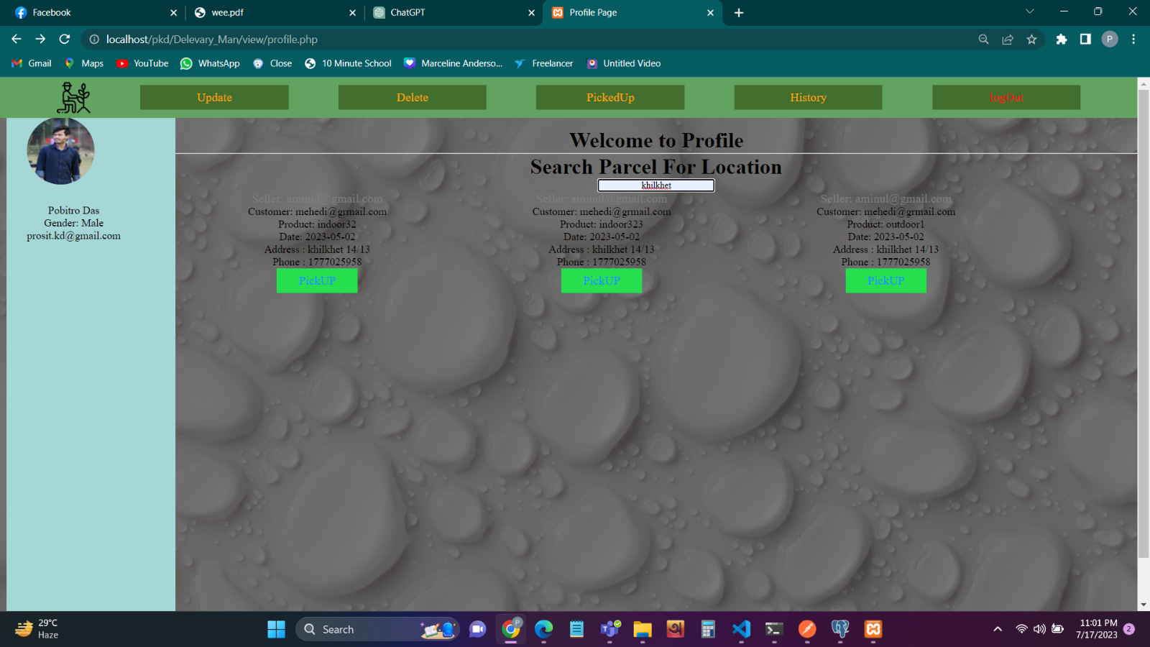

A delivery person, you can search for a parcel or package to ensure that have the correct item for delivery. a few steps you can take to locate a specific parcel.

.

In delivery mans registration the procedure of registration is mostly same as all three registrations the unique part is delivery man has to give information of his transport and has to give choice of his price limit for each kilometer delivery.

In the second page we can see the login page. After giving the email and password which is saved previously. can go to profile page. Here can see profile information. Finally, can logout from profile page from logout option which will take user to login page.

**Impact of this Project:**

*The proposed agriculture digitalization website has the potential to make a positive impact on modern society and the environment by promoting indoor gardening, enhancing plant care knowledge, encouraging sustainable agriculture practices, fostering a sense of community, and providing commercial opportunities for sellers and deliverymen. The project can benefit people by improving their health and well-being, promoting sustainable practices, and enhancing their overall quality of life. Encourage Sustainable.*

*Agriculture: The platform can encourage sustainable agriculture practices by promoting the use of natural and organic gardening products and providing information on sustainable gardening practices.*

*Provide Opportunities for Sellers and Deliverymen: The platform can provide commercial benefits for sellers and deliverymen by providing a platform for them to reach a wider audience and offer their services more efficiently. This can help boost the local economy and provide job opportunities.*

**Limitations and Possible Future Improvements:**

*Here are some possible limitations and areas for improvement:*

1. *Limited Plant Database: The plant identification feature may be limited to certain species or regions. To improve this feature, the website could expand its plant database or incorporate more advanced plant identification technology.*
2. *Language Barrier: The website may be limited to certain languages, which could limit its accessibility to non-native speakers. To address this, the website could incorporate multi-language options or translation services.*
3. *Shipping Limitations: The delivery service may be limited to certain regions or have high shipping costs. To improve this, the website could partner with local delivery services or negotiate better shipping rates.*
4. *Technical Issues: The website may face technical issues, such as server downtime or slow loading times, which could negatively impact user experience. To address this, the website could invest in better server technology or hire technical support staff.*
5. *Lack of User Engagement: The success of the website depends on user engagement and participation. To encourage more user engagement, the website could host online events or contests, offer rewards for active users, or incorporate social media integration.*
6. *Limited Accessibility: The website may be limited in terms of accessibility for users with disabilities, such as those with visual or hearing impairments. To improve accessibility, the website could incorporate features such as text-to-speech or closed captioning.*

*Overall, the proposed agriculture digitalization website has the potential to make a positive impact on society and the environment. By addressing the limitations and incorporating improvements, the website could become an even more valuable resource for plant care information, buying and selling services, delivery services, and community engagement.*

|  |  |  |  |  |  |
| --- | --- | --- | --- | --- | --- |
| CO1.1 and CO2.1 Evaluation: Project Report Evaluation | | | | | |
| Project Proposal  (5) | Background  Study  (5) | Requirement Analysis  (5) | Entity  Diagram  (5) | System Images  against the  Specification (5) | Total (25) |
|  |  |  |  |  |  |
|  | | | | | |